- TEM Results:
C2027,3,32,2,5; C2027,3,32,3,4; C2027,3,32,3,8:
- all three TEM grids show low-Ca pyroxene, namely enstatite
- varying clino- and orthoenstatite fields, with a dominance of CLEN
- C2027,3,32,3,8 also shows evidence for protoenstatite as a precursor – PEN to CLEn transformation
See: Schmitz & Brenker (2008) “MICROSTRUCTURAL INDICATIONS FOR PROTOENSTATITE PRECURSOR OF COMETARY MgSiO3 PYROXENE: A FURTHER HIGH-TEMPERATURE COMPONENT OF COMET WILD 2.” ApJL, Vol. 681, L105-L108.

- C2027,3,32,3,8 also shows an “unknown” mineral phase enclosed by the enstatite (FIG.1):
- The difference in chemistry in comparison to the enstatite is obvious: less Mg (Mg/Si=0.646) higher Al (Al/Si=0.032) and also the occurrence of trace elements Mn and Ti (these were not detected in the enstatite) – see ternary diagram (FIG.1)
- From chemistry it is consistent with saponite, but no microstructural evidence could be find (one diffraction pattern showed 10.2 A d-spacings which could be related to the shrinkage of the (001) spacings of saponite); EELS was also performed but didn’t show a pre-peak of the O-K edge at 528 keV that represents OH⁻ or H₂O in hydrous minerals)

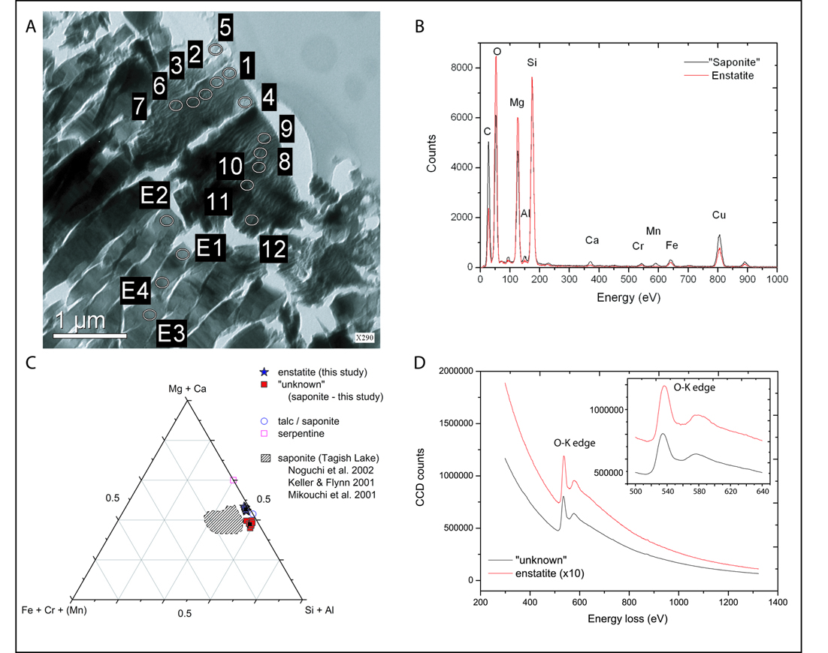
Figure 1: A) Overview of enstatite lamellae and enclosed curved "unknown" mineral phase in BF TEM modus including the measurement points; (B) Si-normalizes EDX spectra of enstatite and the "unknown" taken for 100 sec; (C) ternary diagram including some reference data obtained from Noguchi et al. 2002; Keller & Flynn, 2001; Mikouchi et al. 2001; (D) EEL spectra of the enstatite and "unknown" showing the O-K edge at 532 eV but no pre--peak at 528 eV which is typical for hydrous mineral phases.

C2092,2,80,48,7; C2092,2,80,50,4:

- Both TEM grids show mostly melted Aerogel including Fe, Ni metals and Fe, Ni sulphide droplets
- S-enrichment towards the rim (see ternary diagram FIG.2)
- Also seen in EFTEM pictures

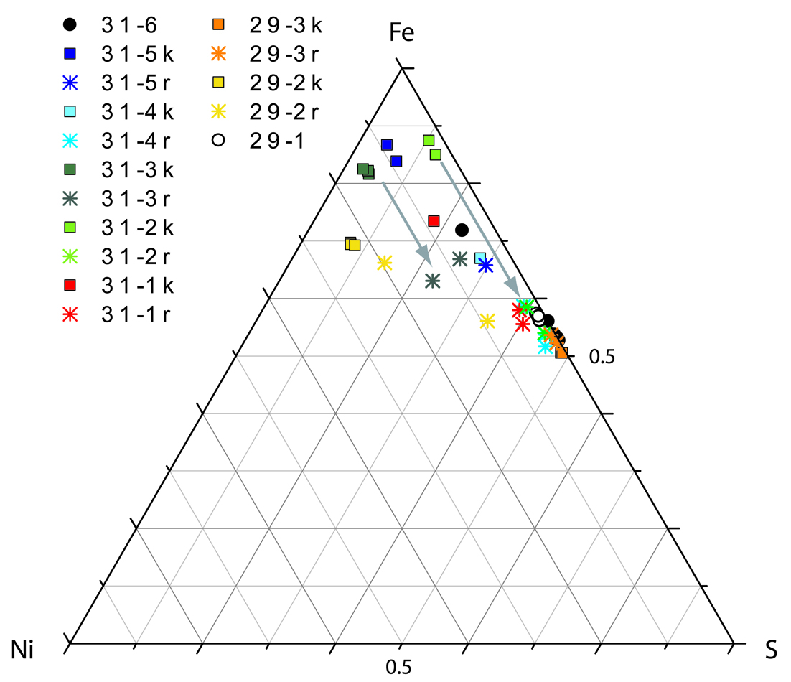
Figure 2: Fe, Ni, S ternary composition diagram (at. %) for opaque inclusions in a silica--rich matrix. The cores (k) are depleted in S whereas the rims (r) are enriched in S. The core represent metal cores or low--S Fe, Ni droplets and the rims are consistent with FeS (pyrrhotite).

- Synchrotron XRF on cometary material:
>C2044,0,37 – 3D nanotomography
See: Silversmit et al. (2009) “X-ray fluorescence nanotomography on cometary matter from comet 81P/Wild2 returned by Stardust.” Anal. Chem. DOI:10.1021/ac900507x
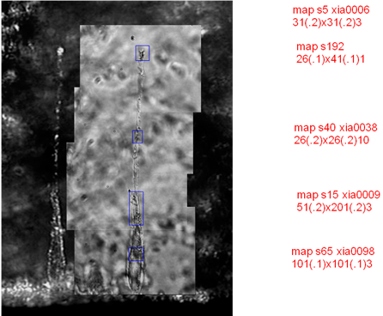
Figure 3: Track C2044,0,37 with a terminal particle at the end and different areas along the track with small fragments of only a few hundreds of nm.
The impact track C2044,0,37 (FIG. 3) was measured in conventional detection mode. Three different areas along the track are mapped in greater detail (stepsize between 100nm and 200nm) and are shown in Figure 4. Several fragments are located along the track showing enrichment in Fe, Ni and Cr and also in Ca.
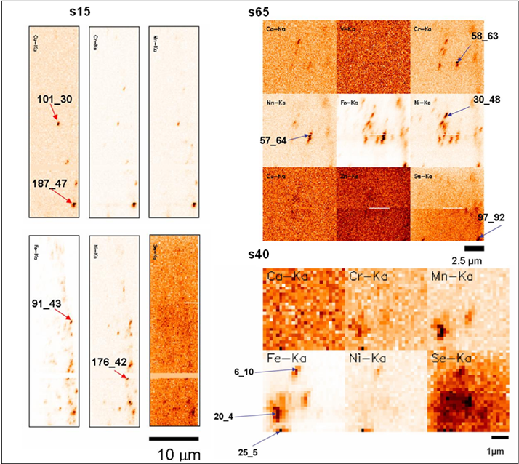
Figure 4: Areas that are indicated in Figure 3 are scanned in detail. Espescially s65 shows fragments along the track with sizes of only a few hundreds of nm. stepsize between 100 and 200nm.
The platelike 3D distributions of chromium and iron in the terminal grain (FIG. 5) resemble the structure of cryptocrystalline olivine-pyroxene chondrules. This interpretation is further supported by recent findings of chondrule-like objects in Wild2 (see: Nakamura et al. 2008) which is a further strong argument for large-scale mixing within the protoplanetary disk. As demonstrated by the aforementioned example on this unique cometary material, the submicroscopic 3D reconstruction of trace-level elemental distributions within this 2 µm individual particle not only reveals the heterogeneous nature of the analyzed cometary grain, but also enables one to distinguish between elemental constituents originally present in the cometary matter and those present as impurities within the embedding aerogel host matrix.
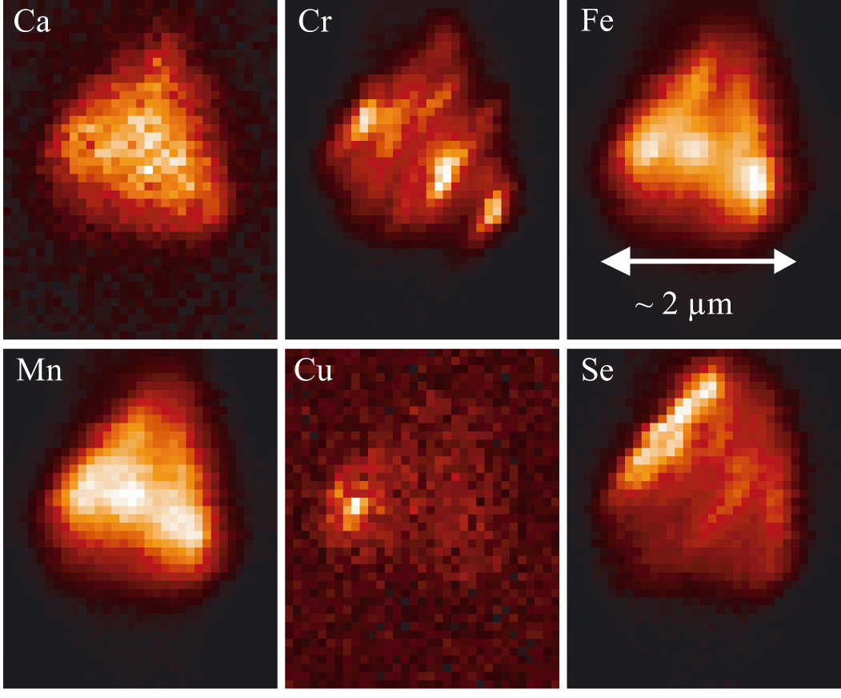
Figure 5: Scaled 2D maps for the most abundant major/minor and trace elements in the XRF spectra of the terminal particle of Track n° C2044,0,37. Cr and Fe (Mn) show platelike distribution.
The terminal particle studied in this work shows a selenium enrichment surrounding the top of the grain, which is a clear indication for compressed aerogel in front of the impacted comatery dust particle. The selenium distribution clearly forms a shell around the particle that does not originate from the particle itself. XRF measurements on the aerogel collectors used to capture the particles revealed the presence of trace levels of selenium, which represents the most likely origin of the Se lines within the measured nano-XRF spectra. The detected Se-rich external layer surrounding the particle is attributed to the partial melting and subsequent solidification of the aerogel around the terminal particle, as a result of the high-speed impact of the comet coma particle. During its high-speed capture in the aerogel collector, the particle is decelerated from its original relative speed of 6.1 km/s, melting and compacting the aerogel matrix along its penetration path. This leads to the increased density of the aerogel around the terminal particle and also increased the volume concentration level of trace elements present in the aerogel (such as selenium), resulting in the observed selenium-rich shell (FIG. 6).
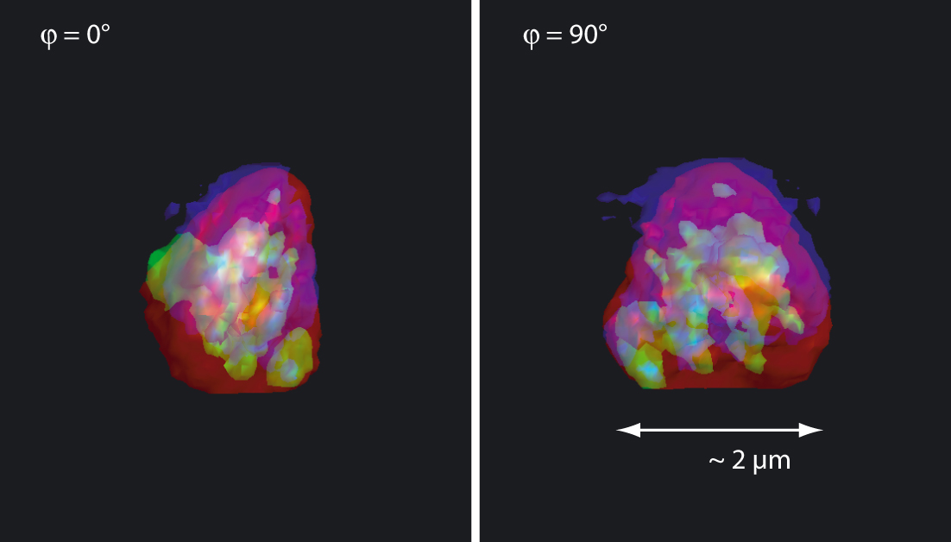
Figure 6: econstructed low-intensity isosurface composite images for different azimuthal viewing angles: red denotes iron, green represents chromium, and blue indicates selenium.

>C2012,0,110,0,0 – CAI like candidate detected:
See: Schmitz et al. (2009) “In situ identification of a CAI candidate in 81P/Wild 2 cometary dust by confocal high resolution synchrotron X-ray fluorescence.” Geochim. Cosmochim. Acta; DOI: 10.1016/j.gca.2009.06.008
For the two largest particles of the track, the terminal particle (Arthur) and a second particle (Marvin) along the impact track (see FIG. 7), Ca concentration is up to 30 times higher than CI and Ti is enriched by a factor of 2 compared to CI. High resolution (HR) SR--XRF mapping also reveals that the highest concentrations of Ca, Ti, Fe (and Ni) measured within each grain belongs to different areas of the respective maps which indicate that the particles are composed of several chemically diverse mineral phases (see FIG. 8). This is in agreement with the CAI grain "Inti" of Track 25.
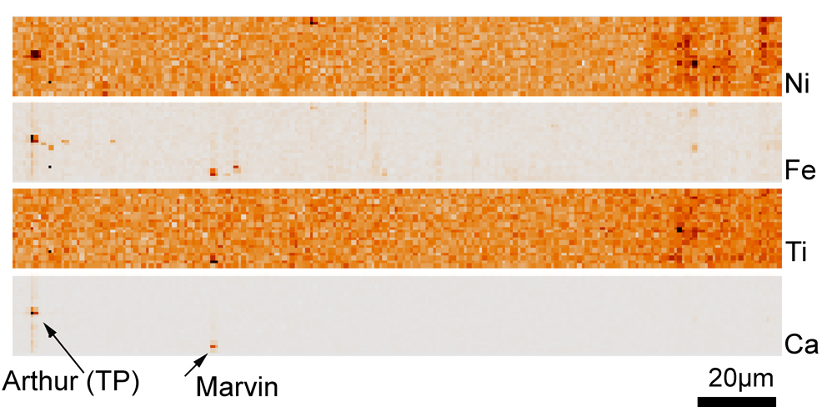
Figure 7: Track 110 with terminal particle Arthur and second Ca, Ti rich particle Marvin. All fluorescence-lines presented as Kα.
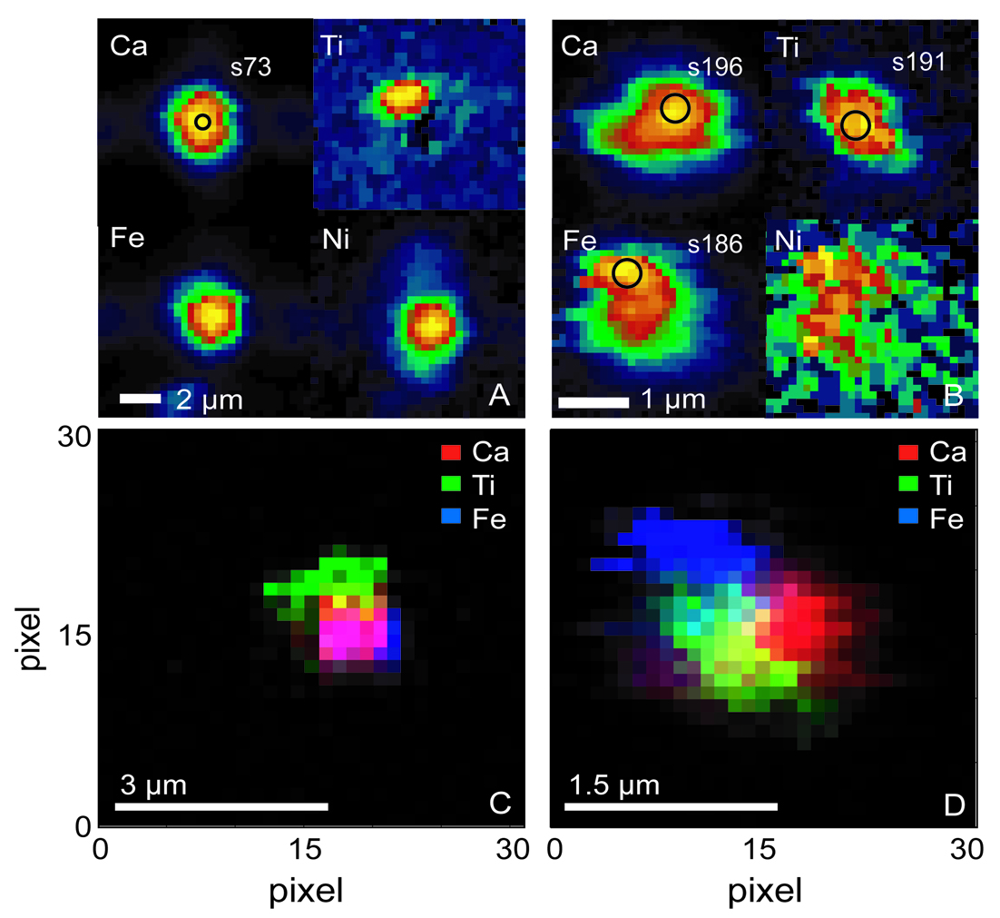
Figure 8: Top: Confocal 2D XRF maps for the TP Arthur (A) and for the grain Marvin (B) for the elements Ca, Ti, Fe and Ni. The circles indicate the spot measurement positions (not to scale). Below: The RGB maps including the elements Ca, Ti and Fe show different hotspots in elemental concentrations related to a polyphase mineral character. Especially for Marvin it is clear that the three elements are uncorrelated.

First order results from the FPM quantification of seven point spectra (s66-s68, s73, s186, s191, s196) are obtained in the confocal detection mode from the two Ca--rich particles (Marvin and Arthur).
Arthur: the region of highest count rate, reflecting that the fluorescence radiation came from the total volume of the particle at this point. The Ca concentration was calculated to 27 wt.% (Ti=0.1, Fe=2.58, Ni=0.12, Mn=0.14 wt.%). Marvin: The Ca concentrations for s191 and s196 vary between 13 and 13.5 wt.%, Ti and Fe are approx. 1 wt.%. In comparison to Arthur, the Ni concentration is only 52 ppm at s196 and 140 ppm at s191. The point measurement s186 shows lower concentrations for all elements: Ca=0.16, Fe=1.68, Ti and Ni 0.03 (all in wt.%) possibly representing a different (Mg-, Al, and/or Si-rich) mineral phase or another measurement that was performed at the surface of the grain revealing similar problems as for the TP (s66-s68).
Principle component analysis (PCA) is a powerful tool for extracting the dominant mineral components and was applied to the two grains indicating that regions in the terminal particle and the second particle are consistent with anorthite or grossite and gehlenite, monticellite or Dmitryivanovite (CaAl₂O₄), respectively.

>C2009,21,92 – Fe, Ni rich particle:
The track (~ 220µm in length) was fully scanned using the conventional (FIG. 9) and confocal detection mode. Fe, Ni rich terminal particle was detected with additional Mn & Cr content.
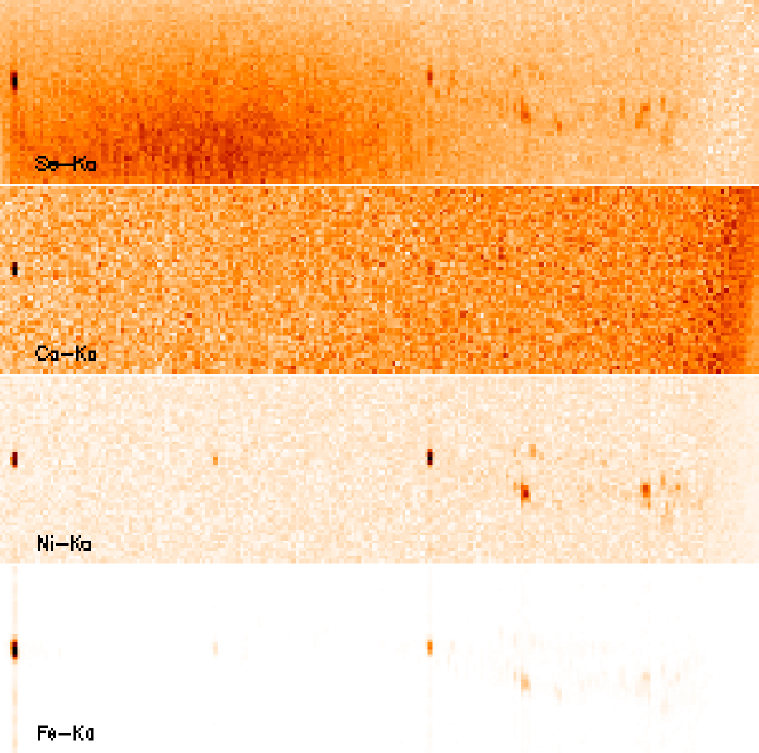
Figure 9: Track C2009,21,92 in the conventional detection mode for Fe, Ni, Ca and Se-Ka lines

